[https://gateoverflow.in/374453/go-classes-test-series-2023-programming-test-2-question-12?show=388123#c388123](https://gateoverflow.in/374453/go-classes-test-series-2023-programming-test-2-question-12?show=388123" \l "c388123)

[Programming: GO Classes Test Series 2023 | Programming | Test 2 | Question: 10 (gateoverflow.in)](https://gateoverflow.in/374455/go-classes-test-series-2023-programming-test-2-question-10)

[Programming: GO Classes Test Series 2023 | Programming | Test 2 | Question: 8 (gateoverflow.in)](https://gateoverflow.in/374457/go-classes-test-series-2023-programming-test-2-question-8)

[In C,why is multiple declarations working fine for a global variable but not for a local variable? - Stack Overflow](https://stackoverflow.com/questions/15734699/in-c-why-is-multiple-declarations-working-fine-for-a-global-variable-but-not-for)  
[Understanding and fixing compiler and linker errors - Cprogramming.com](https://www.cprogramming.com/tutorial/compiler_linker_errors.html)

 the program without main() will surely compile but there will be a linker error.

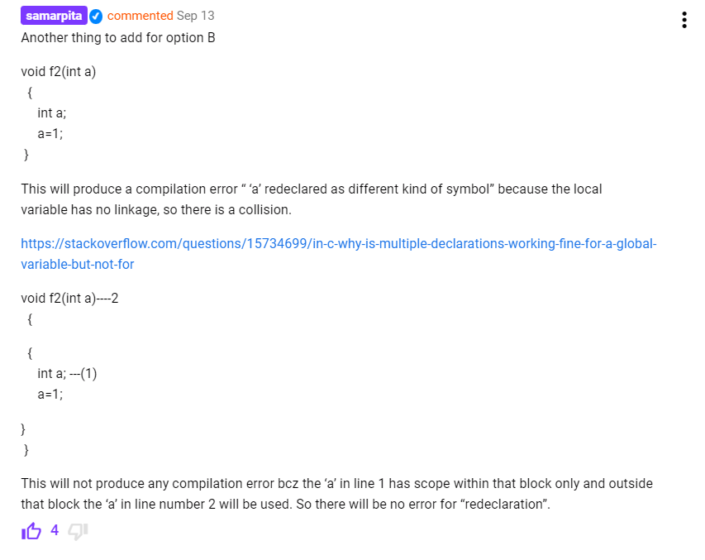

[Programming: GO Classes Test Series 2023 | Programming | Test 2 | Question: 9 (gateoverflow.in)](https://gateoverflow.in/374456/go-classes-test-series-2023-programming-test-2-question-9)

[Programming: GO Classes Test Series 2023 | Programming | Test 2 | Question: 7 (gateoverflow.in)](https://gateoverflow.in/374458/go-classes-test-series-2023-programming-test-2-question-7)

[Programming: GO Classes Test Series 2023 | Programming | Test 2 | Question: 6 (gateoverflow.in)](https://gateoverflow.in/374460/go-classes-test-series-2023-programming-test-2-question-6)

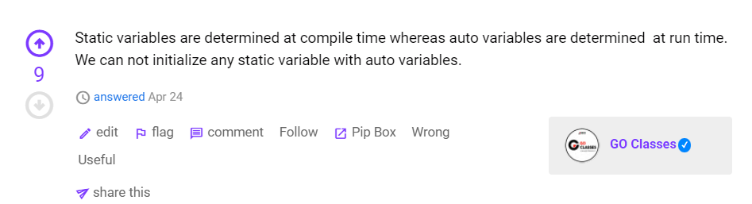

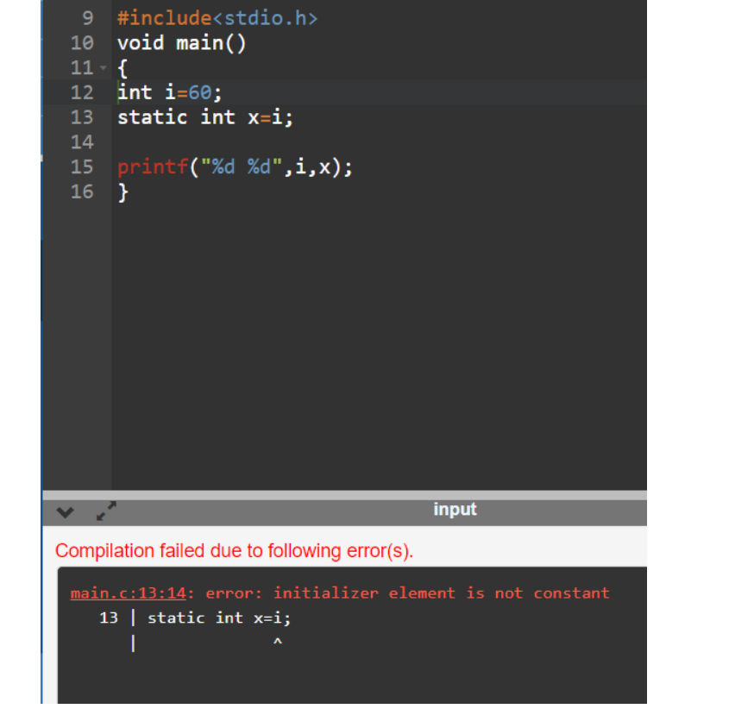

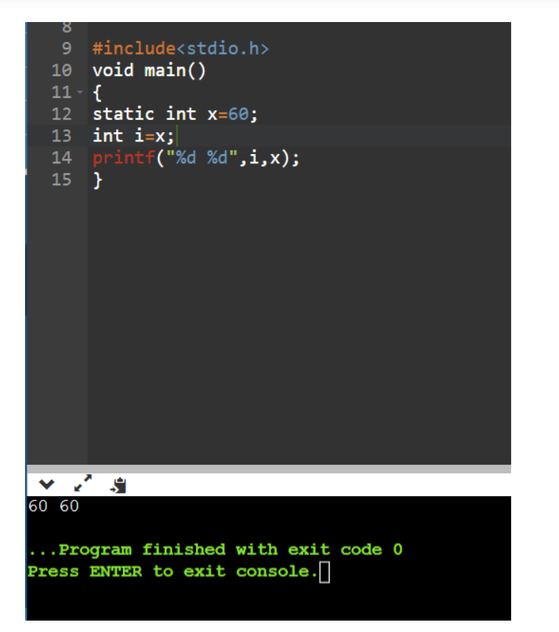

[Programming: GO Classes Test Series 2023 | Programming | Test 2 | Question: 4 (gateoverflow.in)](https://gateoverflow.in/374463/go-classes-test-series-2023-programming-test-2-question-4)

[Programming: GO Classes Test Series 2023 | Programming | Test 2 | Question: 5 (gateoverflow.in)](https://gateoverflow.in/374462/go-classes-test-series-2023-programming-test-2-question-5)

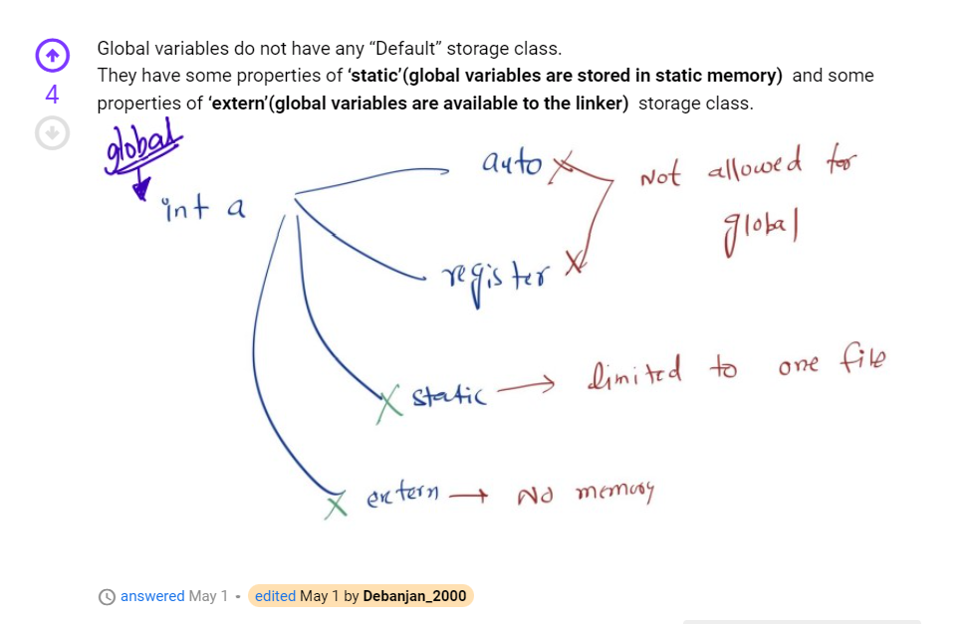

[c - Why won't extern link to a static variable? - Stack Overflow](https://stackoverflow.com/questions/2841762/why-wont-extern-link-to-a-static-variable)  
The whole and entire purpose of static is to declare that a variable is **private to the source file that it is declared in**.

Static is completely private to this file. It is not visible to externs in other files, and you can have many different files that all declare static TYPE blah;, and they are all **different**.

<https://gateoverflow.in/374465/go-classes-test-series-2023-programming-test-2-question-2?show=388164#c388164>

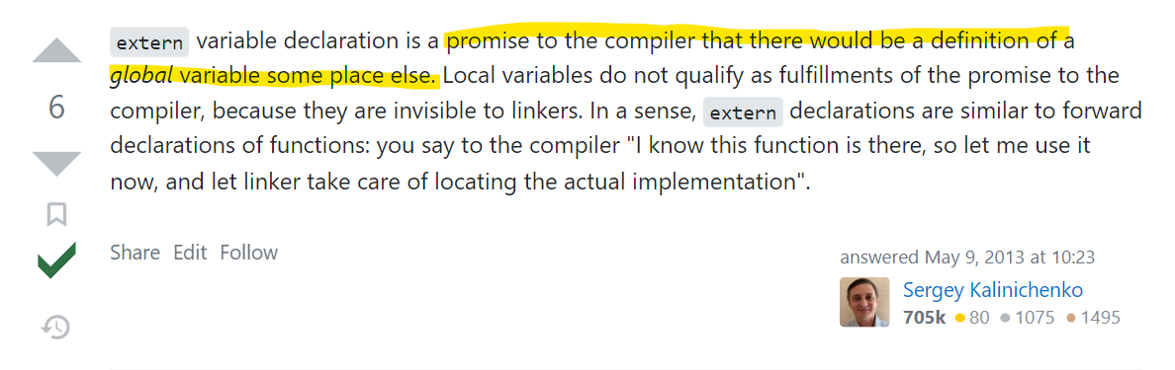

<https://gateoverflow.in/374466/go-classes-test-series-2023-programming-test-2-question-1?show=388166#c388166>

<https://gateoverflow.in/374437/go-classes-test-series-2023-programming-test-2-question-25?show=388211#c388211>

<https://gateoverflow.in/374440>